9.E-BOOK MANAGEMENT SYSTEM

COMPONENT DIAGRAM

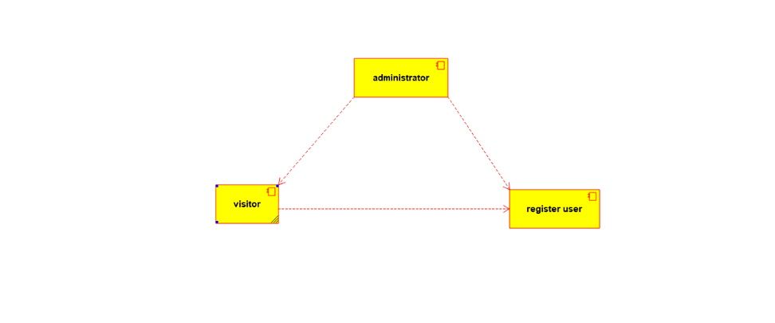

ACTIVITY DIAGRAM

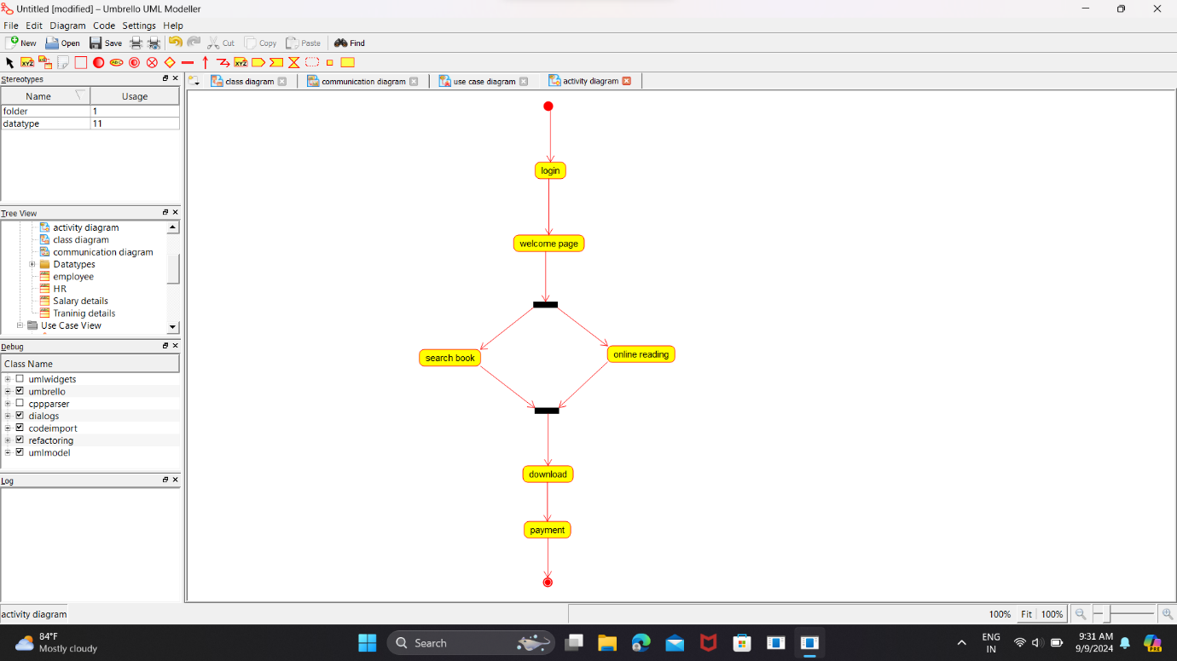

SEQUENCE DIAGRAM

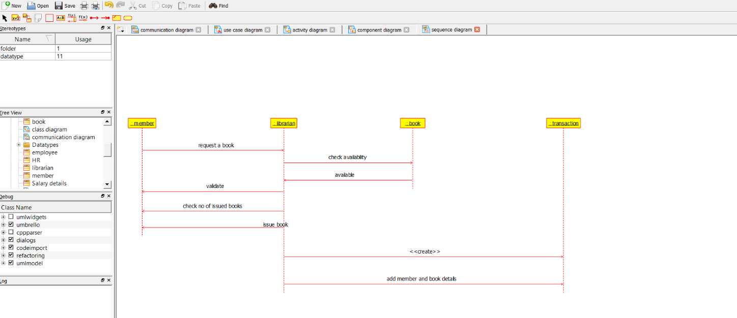

USECASE DIAGRAM

